# COMSATS University Islamabad, Abbottabad Campus - CUI Abbottabad

TITILE: LAB TASK

SUBJECT: OOP’S

REG.NO: SP23-BSE-109

SECTION: 3B

SUBMITTED BY: MAAZ KHAN

SUBMITTED TO: MAAM IQRA SARFRAZ

DEPARTMENT: SOFTWARE ENGINEERING

**Q1:**

A Student is an object in a university management System. Analyze the concept and identify the data members that a Student class should have. Also analyze the behavior of student in a university management System and identify the methods that should be included in Student class.

|  |  |
| --- | --- |
| Class Name | Student, StudentMain |
| Member Data | name, regNo, dateOfBirth, semester, Courses, Marks, gender, section |
| Member function | addCourse(); removeCourse(); addMarks(); removeMarks(); studentInfo(); addStudentinfo(); main(); |

**Q2:**

Time is an intangible concept. Analyze the concept and identify the data members and methods that should be included in Time class.

|  |  |
| --- | --- |
| Class Name | Time, TimeRunner |
| Member data | houre, minute, second |
| Member function | addTime(); displayTime(); main(); |

**Q3:**

Car is an object that helps us in transportation. Analyze the concept and identify the data members and methods that should be included in Car class.

|  |  |
| --- | --- |
| Class Name | Car, CarTransportaion |
| Member data | modelName, year, mileage, fuel, speed, serielNumber, color |
| Member function | acceleration(); brake(); carStop(); refuel(); start(); main(); |

**Q4:**

Rectangle is an object that represents a specific shape. Analyze the concept and identify the data members and methods that should be included in Rectangle class.

|  |  |
| --- | --- |
| Class Name | Rectangle, RectangleMain |
| Member data | Length, width, Area |
| Member function | Rectangle(); calculateArea(); displayArea(); main(); |

**Q5:**

Write an application that asks the user to enter two integers, obtains them from the user and prints their sum, product, difference and quotient (division).

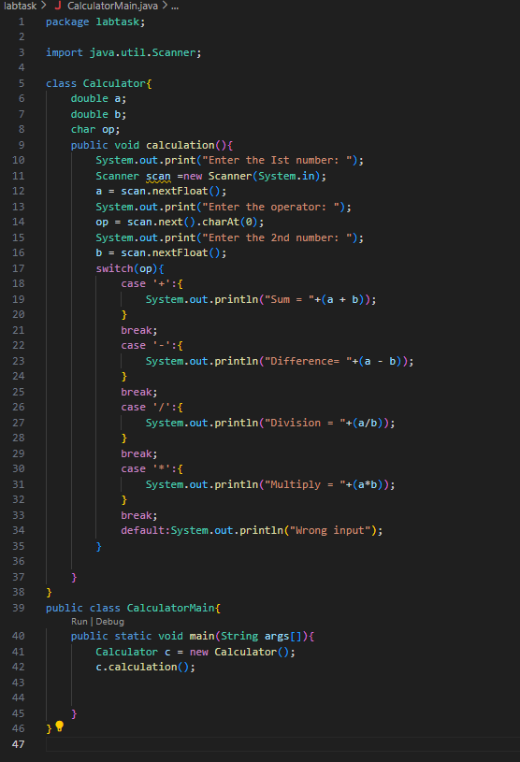

**Q6:**

Write an application that reads an integer and determines and prints whether it’s odd or even. [Hint: Use the remainder operator. An even number is a multiple of 2. Any multiple of 2 leaves remainder of 0 when divided by 2.]

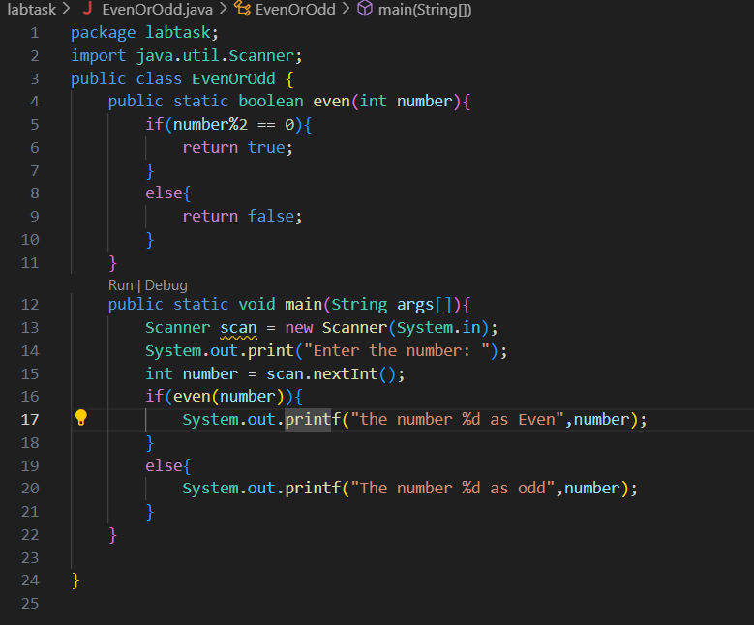

**Q7:**

Write a Java program to declare a double variable and then cast it to an int. Print both the original and the casted values.

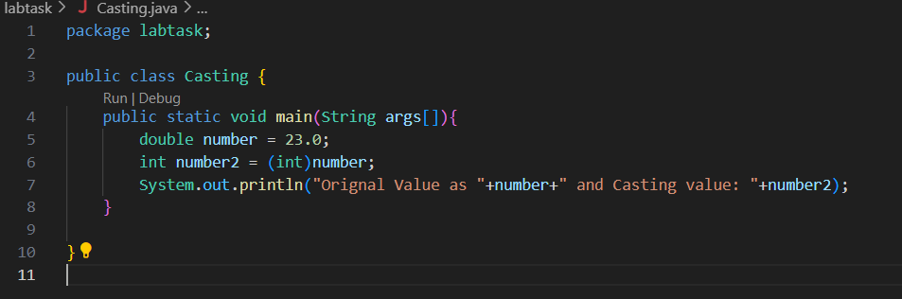

**Q8:**

Write a Java program to demonstrate type casting in arithmetic operations. Perform arithmetic operations between int and double variables and cast the result to int and double.

